Note: As current version of CM 5.10.1 and we need 5.11 and higher to install Spark2 release 3, we can align this activity along with prod upgrade.

#################################

Pre-requisites:

CDH Version:

Required: CDH 5.9 and any higher CDH 5.x versions

Current: 5.10.1 (After upgrade cluster will be on 5.14.4 Version)

Cloudera Manager Version:

Required: Cloudera Manager 5.11 and higher

Current: After upgrade CM version will be 5.14.4

Scala Version:

Require: Spark2 does not work with scala 2.10. Use 2.11 only

Current: 2.10.5, After installing Spark2 it will be 2.11

Python:

Required: Python 2.7 and higher if using python2

Current: 2.6.6, we need at least 2.7 and higher( with 2.6.6 working perfectly fine in Nonprod environment)

Java:

Required: CDS 2.2 and higher require JDK 8

Current: 1.8.0_121

Installation:

1. Login to Cloudera Manager UI, put the cluster in Maintenance Mode
2. Login to Cloudera Manager Node: azrudb7000.ra.rockwell.com
3. cd /opt/cloudera/csd
4. sudo wget <http://archive.cloudera.com/spark2/csd/SPARK2_ON_YARN-2.3.0.cloudera3.jar>
5. sudo chown cloudera-scm:cloudera-scm SPARK2_ON_YARN-2.3.0.cloudera3.jar
6. sudo chmod 644 SPARK2_ON_YARN-2.3.0.cloudera3.jar (by default it will be permissions will be 644 only, better to verify once)
7. Restart cloudera-scm-server

i ) service cloudera-scm-server status

ii) service cloudera-scm-server restart

iii) service cloudera-scm-server status

1. Login into Cloudera Manager Web UI → Click on “Parcels”
2. Click on “Check for New Parcels”
3. For Spark2, select Download, Distribute and Activate the parcel
4. In “Cloudera Manager” Web UI Page, click on “RAPROD” , “Add a service” → Select Spark2
5. Select Dependency Option: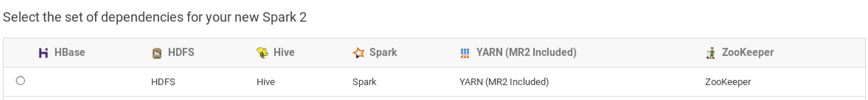
6. Customizing Role Assignments:

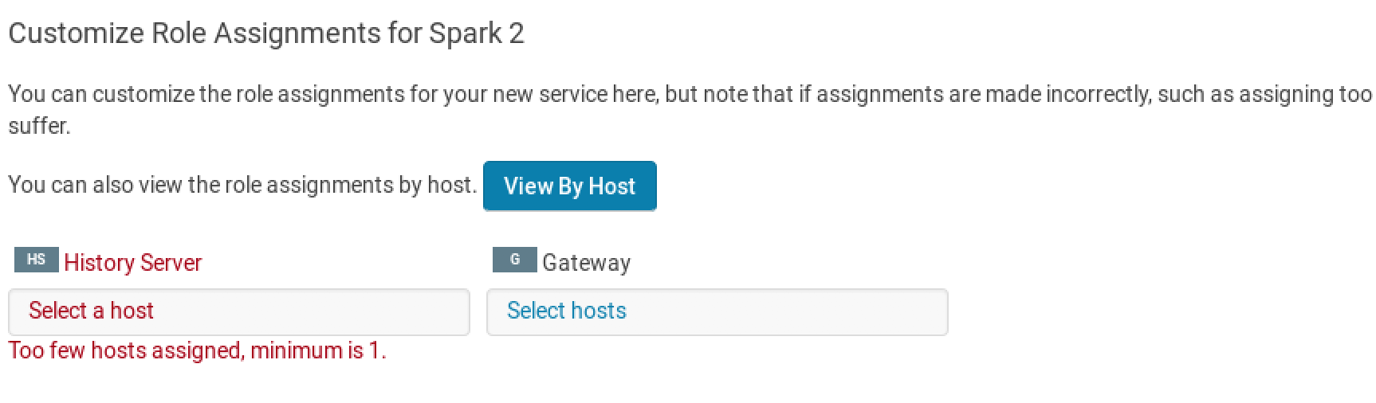

i) History Server: azrudb7001.ra.rockwell.com

ii) Add a gateway role to every host

14) Restart the cluster

15) Run sample job:

spark2-submit --class org.apache.spark.examples.SparkPi --master yarn --deploy-mode cluster /opt/cloudera/parcels/CDH/lib/spark/lib/spark-examples.jar 10

###########################################